MSU Extension’s Six-Step Community Change Model Toolkit

Step 2 guide and worksheet: Bring People Together

Guide: Bring People Together
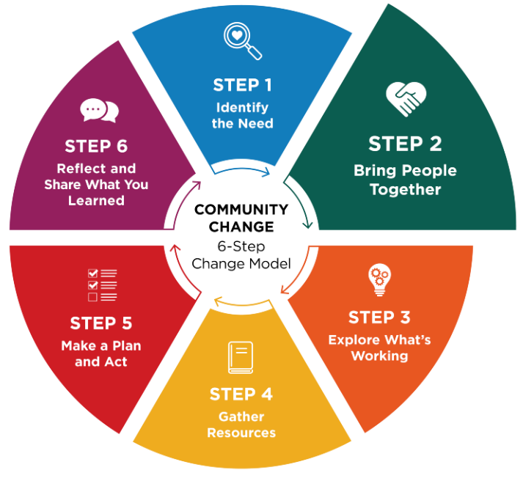
Community champions often act as connectors who help engage overlooked voices, bridge sectors and energize others to turn ideas into action.
Real change happens when people come together, talk openly and listen to those who are closest to the issue. When you create space for honest conversation, about what is working and what could be better, people feel invited to take part. When people feel heard and their ideas matter, they are likely to take ownership. That sense of ownership is what helps change last.

Think about who should be involved
Start by identifying who needs to be part of the conversation from the beginning.
Consider people who:
- Care about the issue.
- Are directly impacted by the issue.
- Make decisions or influence how things are done.
- Understand how the setting works day to day.
- Have valuable insights but may be overlooked.
- Are trusted, motivated and able to help move ideas forward.
For example, local law enforcement officers may understand safety issues that affect food pantry outreach. Youth often offer perspectives adults may miss. Some of these individuals may become community champions.
Having people from different sectors—such as schools, nonprofits, health care, businesses or local government—can help the group share resources and ideas. Using a shared approach, such as the Collective Impact Framework, can strengthen the group’s results.

Questions to help guide your outreach
Ask:
- Who cares about or is impacted by this issue and wants to see improvement?
- Who can help make decisions or influence next steps?
- Who has the time, skills or resources to support this work?
- Who has strong relationships with the people affected?
- Who could help turn ideas into action?
- Who are the philanthropic partners that might support the work?

Identify someone to guide the process
It is helpful to have a dedicated point person who can guide the group and keep the work moving forward. This individual could be someone from your organization or a partner willing to assist. While partners can provide valuable support and guidance, the organization or group closest to the issue should take the lead in decision-making, driving action and sustaining the changes over time.
Tip: Consider using a facilitator
It may be helpful to invite an outside facilitator for your first meeting. A trained facilitator can guide the conversation, help generate ideas, identify challenges and make sure all voices are heard—especially when the group has diverse needs. MSU Extension's team of trained facilitators offers support to community groups through visioning and action planning.

Worksheet: Bring People Together
Identify who should be part of the conversation from the beginning and then periodically as information is gathered, ideas are generated and action is taken. Consider the skills and talents of the team and determine if there is a gap that could be addressed by adding people with that skill or talent.

Identify sectors of interest
Folks may come from different sectors across the community, or they may all come from a single organization. Public sectors to consider are:
- Agriculture
- Childcare
- Commercial marketing/local business
- Community design/planning
- Community members (including youth or elders)
- Education (school, after-school programs)
- Food industry (producers, distributors, and processors)
- Food retailers (grocery, corner store, farmers market)
- Government (local, county, tribal, state)
- Health care (clinics, hospitals, educators)
- Local Food Policy Councils or networks
- Media
- Neighborhood groups
- Public health
- Public safety
- Social/human services
- Transportation
- Other: _______________________________________

Who should be involved?
Write down individuals or organizations who can join you, and how you might reach out to them.

Sector/Group | Specific Individuals or Organizations | Champion(s) to Engage | How We’ll Invite/Engage

Reflection
- Who are the people impacted by the issue and how will their voice be heard?
- Do you have the right people at the table?
- Are any key people or sectors missing from your list who can help make decisions and influence next steps?
- What skills or talents are needed to create the desired changed? Does the team have those skills and talents?

